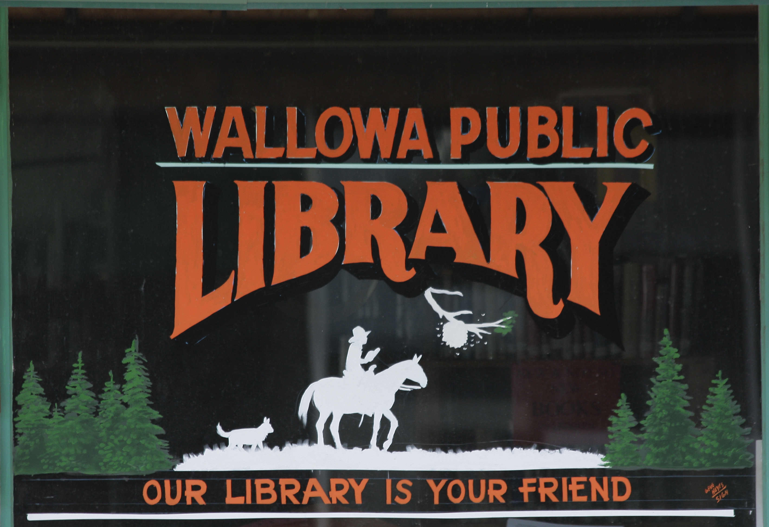

Wallowa Public Library Nondiscrimination Notice
It is the policy of the State of Oregon that unlawful discrimination on the basis of Oregon's protected classes is a matter of state concern, and that such discrimination threatens individual rights and privileges and menaces the institutions and foundations of a free democratic state. (OAR 839.005)
Wallowa Public Library complies with applicable state and Federal civil rights laws and does not discriminate on the basis of protected characteristics in services or employment. Wallowa Public Library does not exclude people or treat them differently because of race, color, national origin, religion, age, disability (physical or mental), sex, sexual orientation, gender identity, or marital status.
- The Library is responsible for providing materials to residents and taxpayers of all ages, backgrounds, and opinions.
- The collection taken as a whole will be an unbiased and diverse source of information, representing as many viewpoints as possible.
- In collection, displays, and programming taken as a whole, the Library neither encourages nor discourages any particular viewpoint.
- No material will be excluded based on a protected class, nor based on the political or social views of the author.
- Selection or display of materials by the Library does not mean endorsement of the contents or the views expressed in those materials.
For more information about the collection process, see the Collection Management Policy available in person at the library, or on the library’s website.
If you think you are being discriminated against at the library, please notify the library director.
If you think you are being discriminated against in any public place doing business with the public in Oregon, you can file a complaint with a state agency. Reach out to the following email address for further assistance: help@boli.state.or.us
Notice: November 13, 2023

